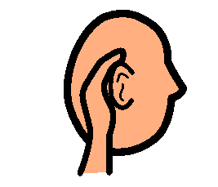
What’s That Sound? Special Education Unit
Contents

Vocabulary board
- This 18 symbol board is intended to be used during class instruction to promote engagement and participation by all students in the class.
- Make one per student. Print on cardstock and laminate for durability.
Books
- With My Ears
  - 11 page story about common sounds
  - Power point format with sounds embedded
- On the Farm I Hear
  - 20 page story about where you hear certain sounds
  - Student booklet: Sounds I Hear book goes along with this story
    - 10 page student booklet where students cut and paste the symbol of what they would hear in each location
Worksheets
- Match picture to word
  - 6 pages include directions and suggestions for students not yet able to read
  - Students match 16 picture symbols to 16 words describing a sound

- Sorting sounds by location
  - Students cut apart 40 picture symbols and sort into 4 locations as to where they would be most likely to hear that sound
  - Directions and suggestions for differentiation are included

- Sorting loud and quiet sounds
  - Students cut apart and sort 20 picture symbols into groups of sounds that are typically loud and those that are typically quiet
  - Directions and suggestions for differentiation are included

What’s that Sound? Activity
- This activity has 2 separate files:
  - Sound clips is a wmv file that contains 20 different sound clips and is approximately 4 minutes in length. Each sound clip is repeated 2 times.
  - Sound clips cards is a pdf file that has directions, picture cards, and an answer key.
- Students are given access to the sound picture cards. As the teacher plays the sound clip file, students try to determine which sound they hear by finding the appropriate picture card.

That’s Too Loud social story
- This 19 page story address a common problem students with disabilities experience which is sensory overload, or more specifically loud noises.
- It gives strategies of how to deal with loud noises and where they may occur in school so students can be prepared.
- Print out a copy to use at school and one to send home. Read daily.

