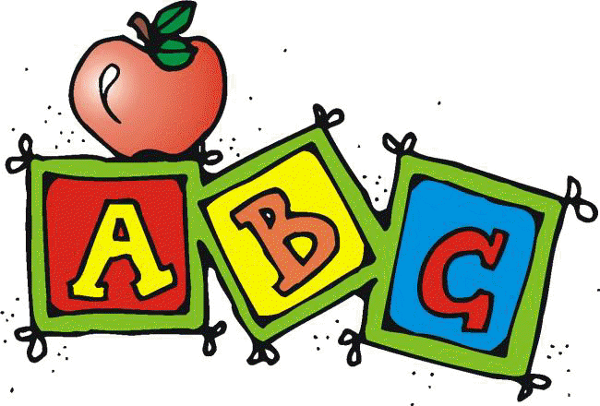
Letter Z Unit Contents

Whole Class Activities
- Alphabet Song
  - A great way to start your lesson and ease issues and disruptions with transition is to have students sing/listen to an alphabet song. I used “The Alphabet’s in my Mouth” by Dr. Jean.
  - Find your favorite ABC chart (good to use the one with Fundations if that is the curriculum you are using) and make a laminated copy for each student.
    - I included one that I used, but any alphabet chart would work
  - Have them follow along on the chart as the song plays. Assist as needed.
- Circle Map
- 6 pages containing
  - Directions
  - 33 color picture symbols
- Scavenger Hunt
  - 2 pages containing
    - Directions with differentiation suggestions
    - Letter symbols
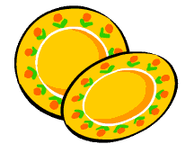
- Pick up the Plates
  - 4 pages containing
    - Directions for 2 variations
    - Differentiation suggestions
    - 24 picture symbols
    - 24 letters

- Craft
  - Students will make a Zinger Water Bottles. Special attention is made to making this as independent an activity as possible for ALL students.
- Cooking Activity
  - Zucchini Muffins
    - 2 picture recipes (easy and more difficult) with directions and ingredient labels.
Books
- Letter Z book
  - 19 page pdf book about the letter Z.
  - Can print out, laminate and bind OR project onto screen or board
- ZZZZ Getting Ready To Go To Bed
  - 21 page book about the steps of getting ready for bed. Also includes a follow up activity.

Printables/Worksheets
- Individual Circle Map
  - 12 picture symbols to cut and paste into a circle map
- Sorting Activities
  - Sorting template (Use the activity that is at your student’s level)
  - 20 picture symbols to sort by initial and middle sound
  - 20 letters in different fonts to sort by letter

- Collage
  - Directions
  - Upper case letter template
- Where is the Letter Z cut and paste book
  - This is an 11 page book (plus 2 pages of directions) that students cut out prepositions and the letter Z in different fonts and pastes in correct locations
  - Lots of visual structure to help increase independence
  - Book utilizes images starting with letter Z to continue to reinforce letter of the week concept

These activities have been very thoughtfully prepared to address the needs of students with significant disabilities. If you are using the Fundations curriculum, this will be a great supplement to your daily lesson. If you find any errors please take a moment to email me through my store so I can make the appropriate corrections and send you a new copy.
www.teacherspayteachers.com/Store/Special-Needs-For-Special-Kids

Day 4
Time | Activity | Materials | Notes
5 min | Alphabet song | - Alphabet song  - Alphabet chart (included)
5 min | Read:  Z Book | - Printed book (included)  OR  - Way to project pdf document | - Every year was different. Some years my kids took sit and listen while I read the story. Some years, they needed the extra stimulation of the book begin projected while I read.
5 min | Fundation Sound cards | - Review letter of the week as well as previous letters covered | - Do only if you currently use this curriculum in your classroom.  - Reviews sounds letters make
10 min | Class Circle Map | - Directions (included)  - Large class circle map  - Letter of the week pictures (included) | - It is important to choose the best number of picture cards to use for your students to keep them engaged and not overwhelmed. For most letters, there are more pictures included than you would want to use in a single day. That is why this activity is repeated daily.
10 min | Class Craft Activity:  Zinger Bottles | - Directions and list of materials (included) | - Special attention is made to make this craft as independent and engaging as possible for students with serious challenges
10 min | Individual Letter Collage | - Directions (included)  - Letter template (included)  - Black construction paper | - Good for fine motor practice and sensory input

