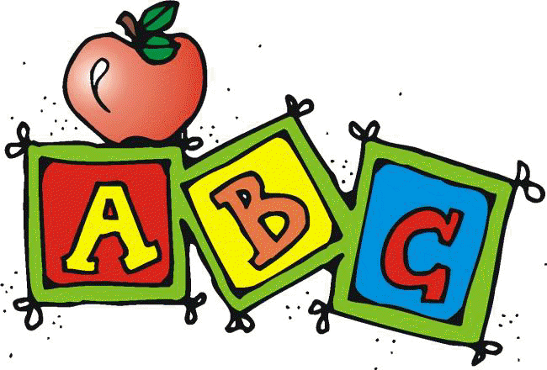
Letter X Unit Contents
Whole Class Activities
- Alphabet Song
  - A great way to start your lesson and ease issues and disruptions with transition is to have students sing/listen to an alphabet song. I used “The Alphabet’s in my Mouth” by Dr. Jean.
  - Find your favorite ABC chart (good to use the one with Fundations if that is the curriculum you are using) and make a laminated copy for each student.
    - I included one that I used, but any alphabet chart would work
  - Have them follow along on the chart as the song plays. Assist as needed.
- Circle Map
- 7 pages containing
  - Directions
  - 35 color picture symbols
- Treasure Hunt
  - 3 pages containing
    - Directions with differentiation suggestions
    - Map symbols
    - Sample treasure map
- Pick up the Plates
  - 4 pages containing
    - Directions for 2 variations
    - Differentiation suggestions
    - 24 picture symbols
    - 24 letters

- Craft
  - Students will make explosive art. Special attention is made to making this as independent an activity as possible for ALL students.
- Cooking Activity
  - Pretzel X
    - Picture recipe with directions and ingredient labels.
Books
- Letter X book
  - 20 page pdf book about the letter X.
  - Can print out, laminate and bind OR project onto screen or board
- Excuse Me, How to Join a Conversation
  - 12 page booklet about helping kids understand how to join an ongoing conversation. Also includes a differentiated sequencing activity.

Printables/Worksheets
- Individual Circle Map
  - 12 picture symbols to cut and paste into a circle map
- Sorting Activities
  - Sorting template (Use the activity that is at your student’s level)
  - 20 picture symbols to sort by sound
  - 20 letters in different fonts to sort by letter

- Collage
  - Directions
  - Upper case letter template
- Where is the Letter X cut and paste book
  - This is an 11 page book (plus 2 pages of directions) that students cut out prepositions and the letter X in different fonts and pastes in correct locations
  - Lots of visual structure to help increase independence
  - Book utilizes images starting with letter X to continue to reinforce letter of the week concept

These activities have been very thoughtfully prepared to address the needs of students with significant disabilities. If you are using the Fundations curriculum, this will be a great supplement to your daily lesson. If you find any errors please take a moment to email me through my store so I can make the appropriate corrections and send you a new copy.
www.teacherspayteachers.com/Store/Special-Needs-For-Special-Kids

Day 5
Time | Activity | Materials | Notes
5 min | Alphabet song | - Alphabet song  - Alphabet chart (included)
5 min | Read:  Excuse Me, How to Join a Conversation | - Printed book (included)  OR  - Way to project pdf document | - I find social stories to be a powerful tool for students. Although this does not directly relate to the letter of the week, it is a good opportunity to address while still reviewing the letter of the week.
5 min | Fundation Sound cards | - Review letter of the week as well as previous letters covered | - Do only if you currently use this curriculum in your classroom.  - Reviews sounds letters make
10 min | Class Circle Map | - Directions (included)  - Large class circle map  - Letter of the week pictures (included) | - It is important to choose the best number of picture cards to use for your students to keep them engaged and not overwhelmed. For most letters, there are more pictures included than you would want to use in a single day. That is why this activity is repeated daily.
10 min | Class Cooking Activity:  Pretzel X | - Directions and list of materials (included) | - So fun, just be check for allergies and make adjustments as needed.
10 min | Join a conversation sequencing | - 2 sets of pictures to allow for differentiation (included) | - This goes along with the social story read at the beginning of the lesson.

