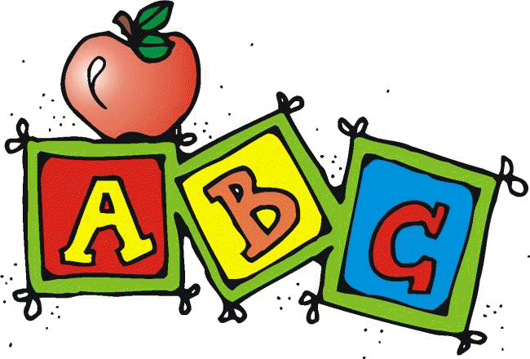
Letter N Unit Contents

Whole Class Activities
- Alphabet Song
  - A great way to start your lesson and ease issues and disruptions with transition is to have students sing/listen to an alphabet song. I used “The Alphabet’s in my Mouth” by Dr. Jean.
  - Find your favorite ABC chart (good to use the one with Fundations if that is the curriculum you are using) and make a laminated copy for each student.
    - I included one that I used, but any alphabet chart would work
  - Have them follow along on the chart as the song plays. Assist as needed.
- Circle Map
- 7 pages containing
  - Directions
  - 36 color picture symbols
- Scavenger Hunt
  - 2 pages containing
    - Directions with differentiation suggestions
    - Letter symbols
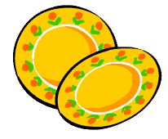
- Pick up the Plates
  - 4 pages containing
    - Directions for 2 variations
    - Differentiation suggestions
    - 24 picture symbols
    - 24 letters

- Craft
  - Students will make a necklace out of noodles that have the letters to spell their name. Special attention is made to making this as independent an activity as possible for ALL students.
- Cooking Activity
  - Nachos

    - Picture recipe with directions and ingredient labels.

Books
- Letter N book
  - 19 page pdf book about the letter N.
  - Can print out, laminate and bind OR project onto screen or board
- Feeling Nervous
  - 16 page book about feeling nervous and how to handle it. Also includes 2 different follow up activities to use with students depending on their learning level.
Printables/Worksheets
- Individual Circle Map
  - 12 picture symbols to cut and paste into a circle map

- Sorting Activities
  - Sorting template (Use the activity that is at your student’s level)
  - 20 picture symbols to sort by initial sound
  - 20 letters in different fonts to sort by letter

- Collage
  - Directions
  - Upper case letter template
- Where is the Letter N cut and paste book
  - This is an 11 page book (plus 2 pages of directions) that students cut out prepositions and the letter N in different fonts and pastes in correct locations
  - Lots of visual structure to help increase independence
  - Book utilizes images starting with letter N to continue to reinforce letter of the week concept

These activities have been very thoughtfully prepared to address the needs of students with significant disabilities. If you are using the Fundations curriculum, this will be a great supplement to your daily lesson. If you find any errors please take a moment to email me through my store so I can make the appropriate corrections and send you a new copy.
www.teacherspayteachers.com/Store/Special-Needs-For-Special-Kids

Day 3
Time | Activity | Materials | Notes
5 min | Alphabet song | - Alphabet song  - Alphabet chart (included)
5 min | Read:  N Book | - Printed book (included)  OR  - Way to project pdf document | - Every year was different. Some years my kids took sit and listen while I read the story. Some years, they needed the extra stimulation of the book begin projected while I read.
5 min | Fundation Sound cards | - Review letter of the week as well as previous letters covered | - Do only if you currently use this curriculum in your classroom.  - Reviews sounds letters make
10 min | Class Circle Map | - Directions (included)  - Large class circle map  - Letter of the week pictures (included) | - It is important to choose the best number of picture cards to use for your students to keep them engaged and not overwhelmed. For most letters, there are more pictures included than you would want to use in a single day. That is why this activity is repeated daily.
10 min | Class Pick up the Plates Activity | - Directions (included)  - Paper plates  - Letters (included)  - Pictures (included) | - This activity, like many other whole class activities, takes advantage of kinesthetic learning. Getting up and moving can be disruptive, but given practice, students can learn to do this calmly and is a great way to assimilate the new information.  - Many of our students also have social goals, so take this time to teach students about taking turns and appropriate game”
10 min | Individual Preposition Coloring Booklet | - Student booklet (included) | - Again, I chose to include this as a weekly activity because so many of my students have a preposition goal they need to work on. This gives me a way to address this goal in a format that is not necessarily math focused.  - I have made the booklet black and white so you can have the option of having students color the pictures. (Most of my students hated to color, so I was more focused on the letter of the week and preposition concept.)

